Coursera Capstone Project

# Introduction and description

Sushi is becoming more and more popular in the Netherlands. For a startup restaurant it would be beneficial to use this trend to make a popular sushi place. The problem is, where in the Netherlands would you start your food chain? In this Capstone Project, the popularity density and house pricing will be mapped per capital to see where the sushi restaurant will gain the most popularity with the least cost. Both individual aspects will be mapped, but also the ratio between them will give a good indication.

Once decided in which province the restaurant will be placed, the sushi places in and around the capital will be mapped and clustered based on their ranking. This data will provide a good estimate on where the sushi-bar can be located best for the least amount of rivalry.

# Data description

To make the corresponding maps, the following data is needed.

GeoJSON data of the Netherlands based on provinces: [<https://www.webuildinternet.com/articles/2015-07-19-geojson-data-of-the-netherlands/provinces.geojson>]

The house pricing in the capital cities in the first quarter of 2019: [<https://www.globalpropertyguide.com/Europe/Netherlands/Price-History>]

The population in the capital cities in 2019: [https://en.wikipedia.org/wiki/Provinces_of_the_Netherlands]

Sushi restaurants location data and rating: API foursquare

# Methodology

The province data and pricings were imported, cleaned and merged together for convenience. The names of the provinces where adjusted to match those of the JSON file. This resulted in Table 1:

Table . Dataframe of the provinces with their corresponding population and house pricing.

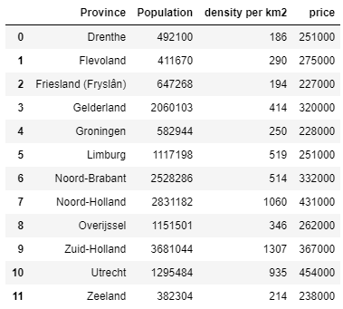

This data was applied to the JSON file to produce a density and pricing map, see Figure 1.

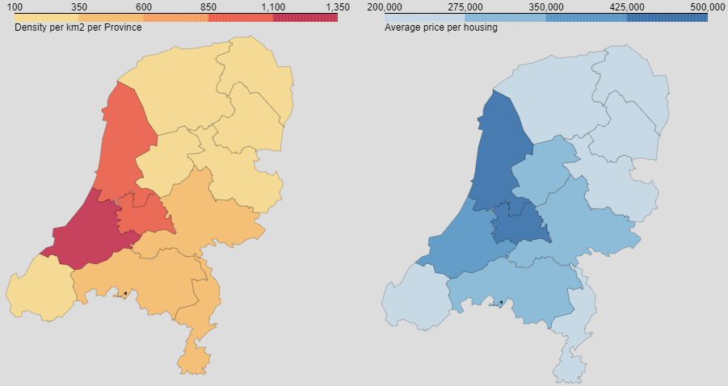

Figure . Left: A map of the population density in the Netherlands. Right: A map of the average price of a house.

Next was the calculation of the ratio between price and population. The initial costs are important for a startup company. But investing more money in a place which will most likely yield more customers is what the next figure will demonstrate, see Figure 2:

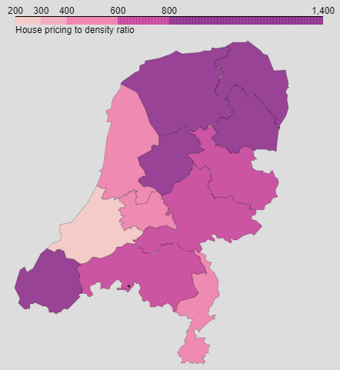

Figure . Ratio between house price and population density in The Netherlands.

From these three maps it was concluded that the restaurant would be most successful in South Holland, for convenience sake we’ll assume the restaurant will be placed inside or near the capital Den Haag.

Sushi restaurants near Den Haag were found by using Foursquare:

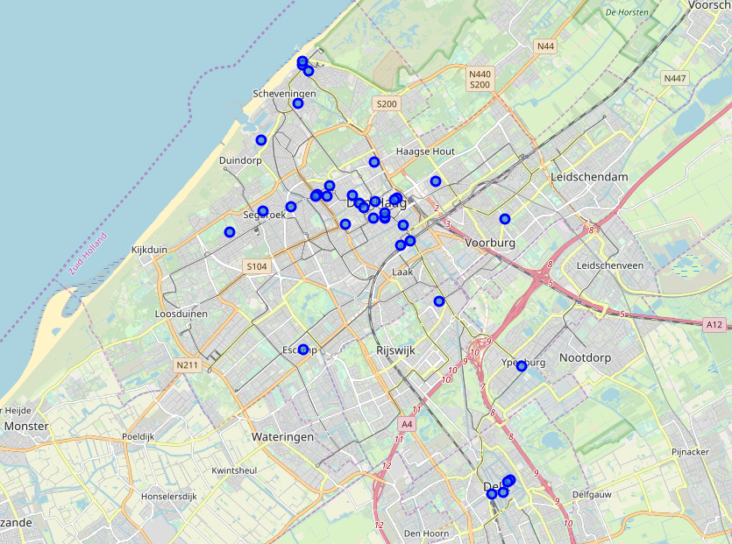

Each of these restaurants were investigated with Foursquare using a loop to determine their rating. The restaurants were clustered using their rating and mapped:

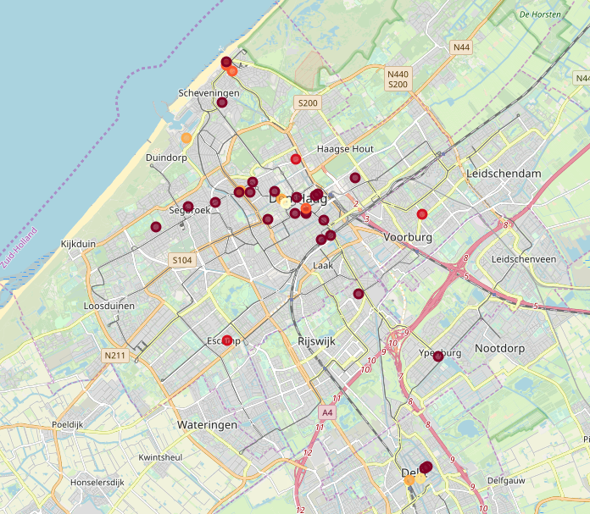

# Discussion

While clustering the restaurant based on their rating it was soon clear that most of these didn’t have a registered rating on Foursquare (these are the darkest spots on the map). This makes it harder to determine where there are already good restaurants present. It is also not known where the most popular spots are in Den Haag. The decision for the restaurant’s place will be based on these analytics alone assuming the density ratio will make up for the already present restaurant.

# Conclusion

From this capstone project it is concluded that the sushi restaurant will be most successful when build around “Duindorp” or “Laak”, see the map down below:

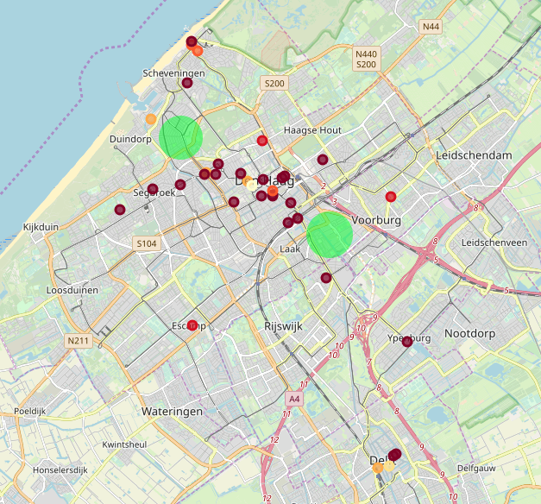

The reason for choosing Den Haag as a province comes from the density of people who live here. More people will result in higher popularity. The places marked on the map are also further away from the already present restaurants which will decrease rivalry. It is however not known if these places are popular among inhabitants.